Distance Measurement Using Laser

Made by:

Bikram Kumar Panda Udbhav Pangotra

Undergraduate, Second Year

Electronics and Telecommunications Engineering

Army Institute Of Technology Pune

Undergraduate, Second Year

Electronics and Telecommunications Engineering

Army Institute Of Technology Pune

TABLE OF CONTENTS

|  |  |  |
| --- | --- | --- |
| Serial. No | Content Title | Page No. |
| 1. | Table of Contents | 1 |
| 2. | Acknowledgements | 2 |
| 3. | List of Figures | 3 |
| 4. | Abstract | 4 |
| 5. | Operation | 7 |
| 6. | Schematic | 8 |
| 7. | Board Layout | 9 |
| 8. | Device Profile | 10 |
| 9. | Bill of Materials | 12 |
| 10. | Future Adaptations | 13 |
| 11. | References | 14 |

Acknowledgements

I am using this opportunity to express my gratitude to everyone who supported me throughout the course of this project. I am thankful for their aspiring guidance and invaluably constructive criticism during the project work.

I express my deepest gratitude to my mentor, Prof. D. V. Gadre for his endless patience and inspiring advice. Also I would like to express my deepest gratitude to my mentors Mrityunjai Sir and Nikita Agarwal ma’am.

I would like to thank everyone at Centre for Electronics Design and Technology, NSIT, New Delhi for their constant cooperation.

Finally, I would also like to thank my family and friends for their constant help and support.

LIST OF FIGURES

|  |  |  |
| --- | --- | --- |
| Figure No. | Description | Page No. |
| 1. | SCHEMATIC OF THE CIRCUIT | 6 |
| 2. | BOARD LAYOUT OF CIRCUIT | 7 |
| 3. | THE WEBCAM AND CAMERA | 8 |
| 4. | CIRCUIT DESIGN | 8 |
| 5. | FABRICATED PCB AS SEEN FROM BELOW | 8 |
| 6. | FABRICATED PCB AS SEEN FROM TOP | 9 |

ABSTRACT

There are many off the shelf range finding components available including ultrasonic, infrared, and even laser rangefinders. All of these devices work well, but in the field of aerial robotics, weight is a primary concern. It is desirable to get as much functionality out of each component that is added to an airframe. Miniature robotic rotorcraft for example can carry about 100g of payload. It is possible to perform machine vision tasks such as obstacle identification and avoidance though the use of a webcam (or mini wireless camera interfaced to a computer via USB adaptor). Better yet, two webcams can provide stereo machine vision thus improving obstacle avoidance because depth can be determined. The drawback of this of course is the addition of the weight of a second camera. This project describes how a mini laser pointer can be configured along with a single camera to provide mono-machine vision with range information.

Just in case you are taking a mortgage and you need to have the exact dimensions of the house in a short duration of time then rather than going through the architecture models and the home design you can use the laser distance meter at that point of time. What the laser meter does is that it gives you the exact dimensions of the plot or the area without going through so much hassles. Automation seems to be everywhere nowadays, whether it is your television, music system, camera, air conditioner and so many other things so why not take away so much of effort and make it easy.

Now being only a laser and a camera the package also is not very difficult to carry and also it won’t be costly so why not use this as a remedy for our pains.

OPERATION

The diagram below shows how projecting a laser dot onto a target that is in the field of view of a camera, the distance to that target may be calculated. The math is very simple, so this technique works very well for machine vision applications that need to run quickly.

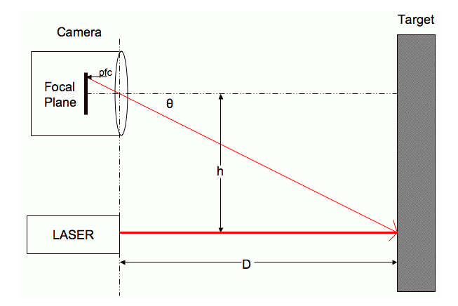

So, here is how it works. A laser-beam is projected onto an object in the field of view of a camera. This laser beam is ideally parallel to the optical axis of the camera. The dot from the laser is captured along with the rest of the scene by the camera. A simple algorithm is run over the image looking for the brightest pixels. Assuming that the laser is the brightest area of the scene (which seems to be true for my dollar store laser pointer indoors), the dots position in the image frame is known. Then we need to calculate the range to the object based on where along the y axis of the image this laser dot falls. The closer to the center of the image, the farther away the object is.

As we can see from the diagram earlier in this section, distance (D) may be calculated:

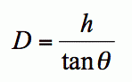

Of course, to solve this equation, you need to know h, which is a constant fixed as the distance between your laser pointer and camera, and theta. Theta is calculated:

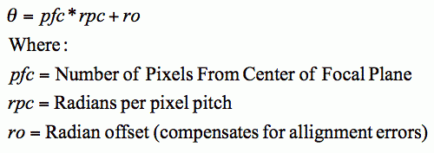

Put the two above equations together, we get:

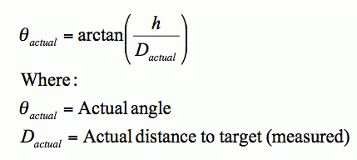

OPENCV

**OpenCV** (*Open Source Computer Vision*) is a [library of programming functions](https://en.wikipedia.org/wiki/Library_(computing)) mainly aimed at real-time [computer vision](https://en.wikipedia.org/wiki/Computer_vision), originally developed by [Intel](https://en.wikipedia.org/wiki/Intel_Corporation) research center in [Nizhny Novgorod](https://en.wikipedia.org/wiki/Nizhny_Novgorod) (Russia), later supported by [Willow Garage](https://en.wikipedia.org/wiki/Willow_Garage) and now maintained by Itseez.The library is [cross-platform](https://en.wikipedia.org/wiki/Cross-platform) and free for use under the [open-source](https://en.wikipedia.org/wiki/Open-source) [BSD license](https://en.wikipedia.org/wiki/BSD_license).

We used OpenCV to find the visual pattern of the laser so that the camera can track the laser point. We OpenCV for Python and used Python to make the final Program.

Our Final Program also uses numpy, math and MySQL class to do the calculation based on arrays and store them in a MySQL table.

SCHEMATIC

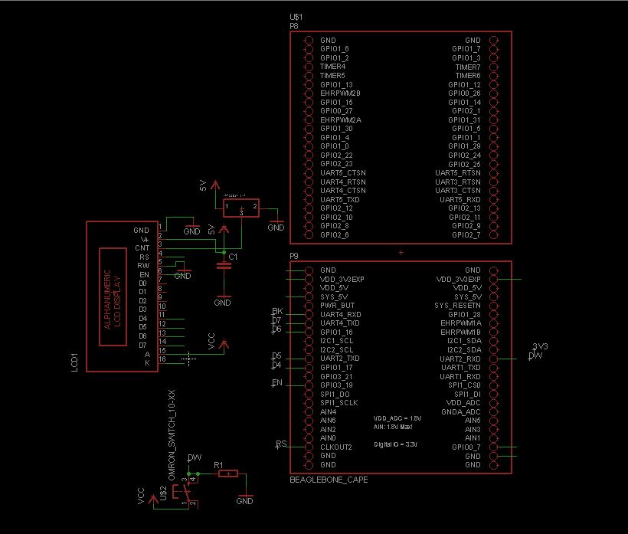

Figure 1: SCHEMATIC OF THE CIRCUIT

BOARD LAYOUT

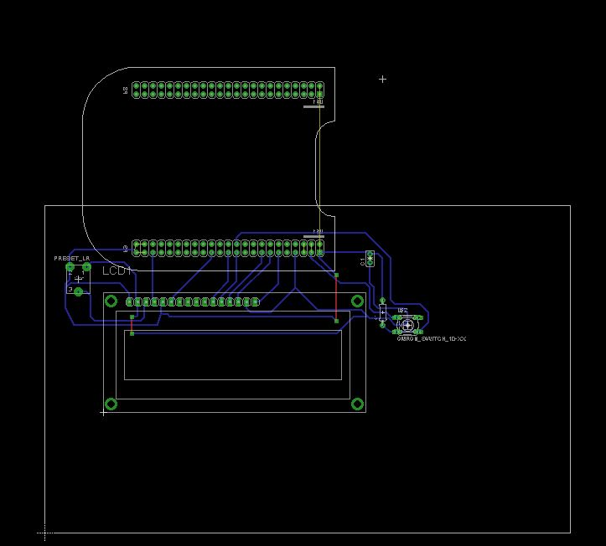

Figure 2: BOARD LAYOUT OF CIRCUIT

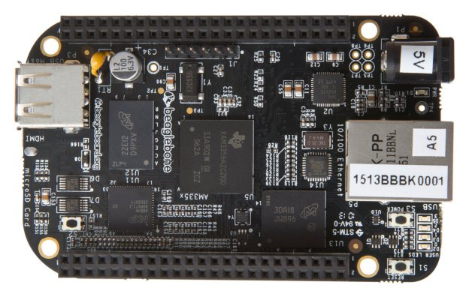DEVICE PROFILE**FigFigure 3:Beagle Bone Black**

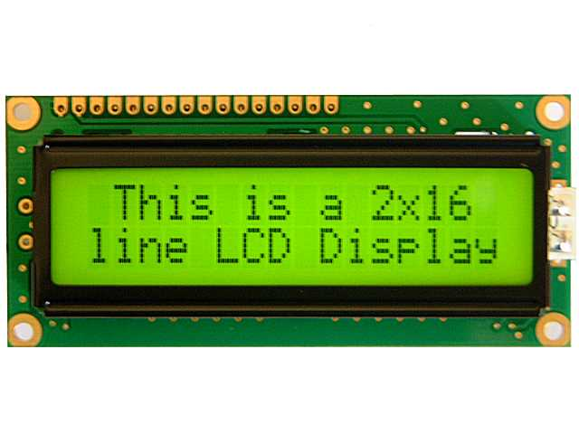

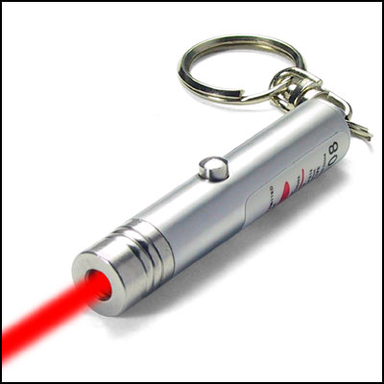

Figure 4: normal Laser

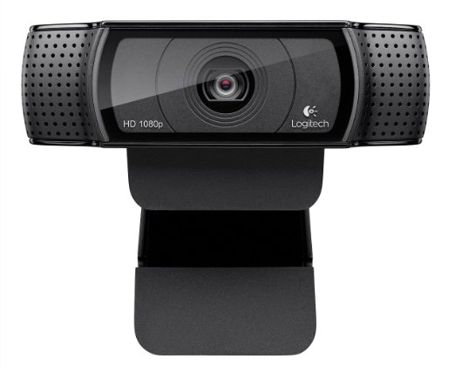

Figure 5:Webcam we used

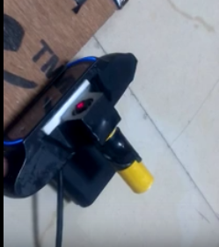

Figure 6:Webcam with laser attached on top

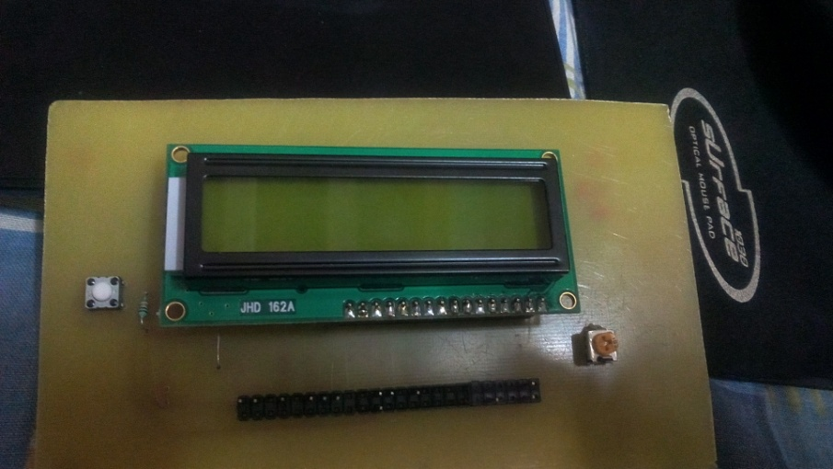

Figure 7:Top of the PCB(Cape)

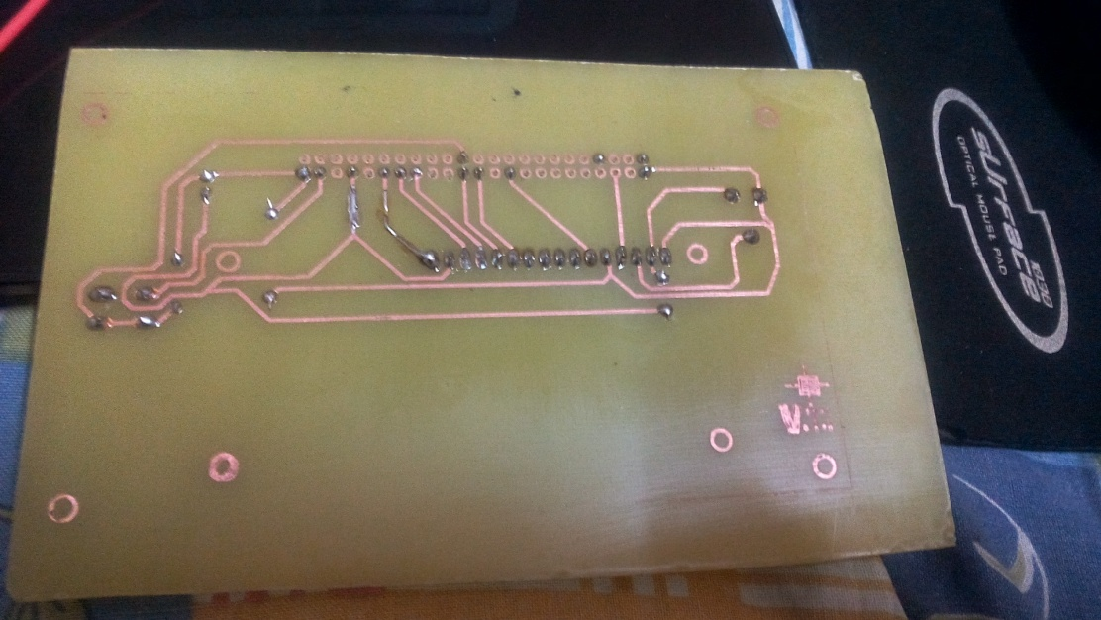

Figure 8:Bottom of the PCB(Cape)

TESTING

Testing is a very crucial part for any project.

A Trial Run Video Has been Uploaded On Youtube :

<https://youtu.be/8nUevIQ-P4o>

BILL OF MATERIALS

|  |  |  |  |
| --- | --- | --- | --- |
| Serial. No | Component | Specification | Quantity |
| 1. | Copper Clad to make a PCB |  |  |
| 2. | Potentiometer | 100k | 1 |
| 3. | Ceramic Capaitor | 0.1 uF | 1 |
| 4. | Webcam |  | 1 |
| 5. | Beaglebone Black |  | 1 |
| 6. | Laser |  | 1 |
| 7. | LCD |  | 1 |

FUTURE ADAPTATIONS

This idea of using a laser-camera combination is to maximize the precision and reduce the cost as much as possible and is of immense practical significance. It can be extended to:

* Remotely have a plot of a room on a 2-D level.
* Remotely have a plot of a room on a 3-D level.
* Remotely have a distance of an object far away on a very high precision.

REFERENCES

* https://en.wikipedia.org/wiki/OpenCV
* https://www.youtube.com/watch?v=fohnf8z2Lac
* https://shaneormonde.wordpress.com/2014/01/25/webcam-laser-rangefinder/